Climate change characterizations comparing the Historic (1910-39) and the Modern (1990-2007) eras
21 Feb 2011.
PRISM climate models at 800m (30 arc second) resolution
ArcGIS 9.3.1
JMP 8.0
R 2.11.1

I. Climate Model basis:
A. PCA on 19 Bioclimatic rasters
Principal Components Analysis is used in Remote Sensing as a data reduction and de-correlation method as it is employed more familiarly in multivariate statistics in ecology. The transformation products are rotated axes or principle components that are de-correlated and organized in decreasing variance with the first component containing most of the variance and the subsequent components containing increased data “noise”.

1.When applying a PCA to the 19 rasters of bioclimatic variables, both sets of historic and current era averages, we recover these components:

 | historic climate | current climate
% recovered  (PC1, PC2, (Cum)) | 53 %, 20.4% (73.4 %) | 52.9%, 21.2 % (74.1 %)
PC1 Variable loadings (in order of eigenvector values) | BIO_10  BIO_9  BIO_1  BIO_5 | BIO_9  BIO_1  BIO_5  BIO_8  BIO_11
PC2 Variable loadings (in order of eigenvector values) | BIO_15  BIO_7 (-)  BIO_13  BIO_16  BIO_19 | BIO_16  BIO_19  BIO_13  BIO_7 (-)  BIO_12

We can also visualize the components by assigning the first PC to the red band and the second to the Green band of a multiband raster, which shows a striking coastal vs. Great Basin division split right down the eastern face of the Sierra Nevada of factor loading:

PCA on historical climate

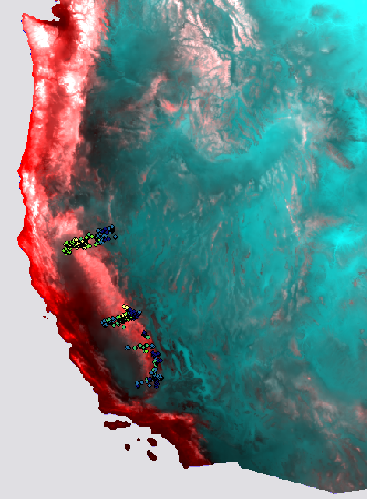

PCA on current climate:

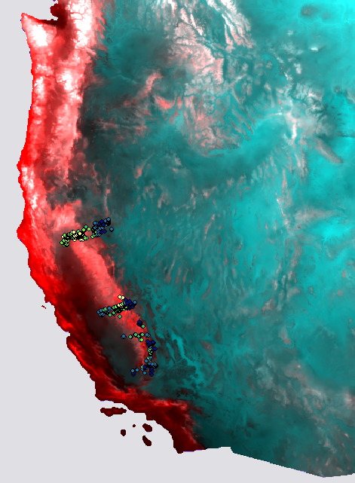

Differences are subtle between eras but are present.

Deltas maps below compare historic and modern Principal component bands where more intense color is greater difference between eras:
PC1 - mostly loading on Temp variables PC2 - mostly loading on Precip variables
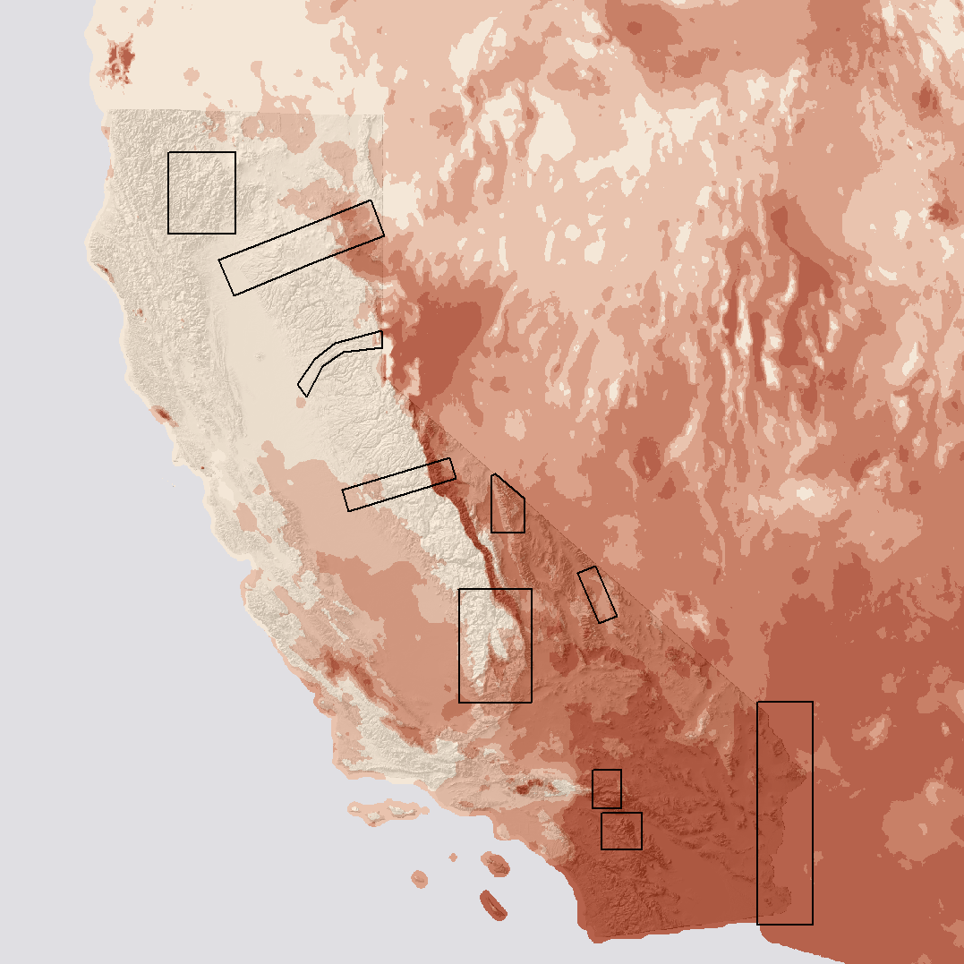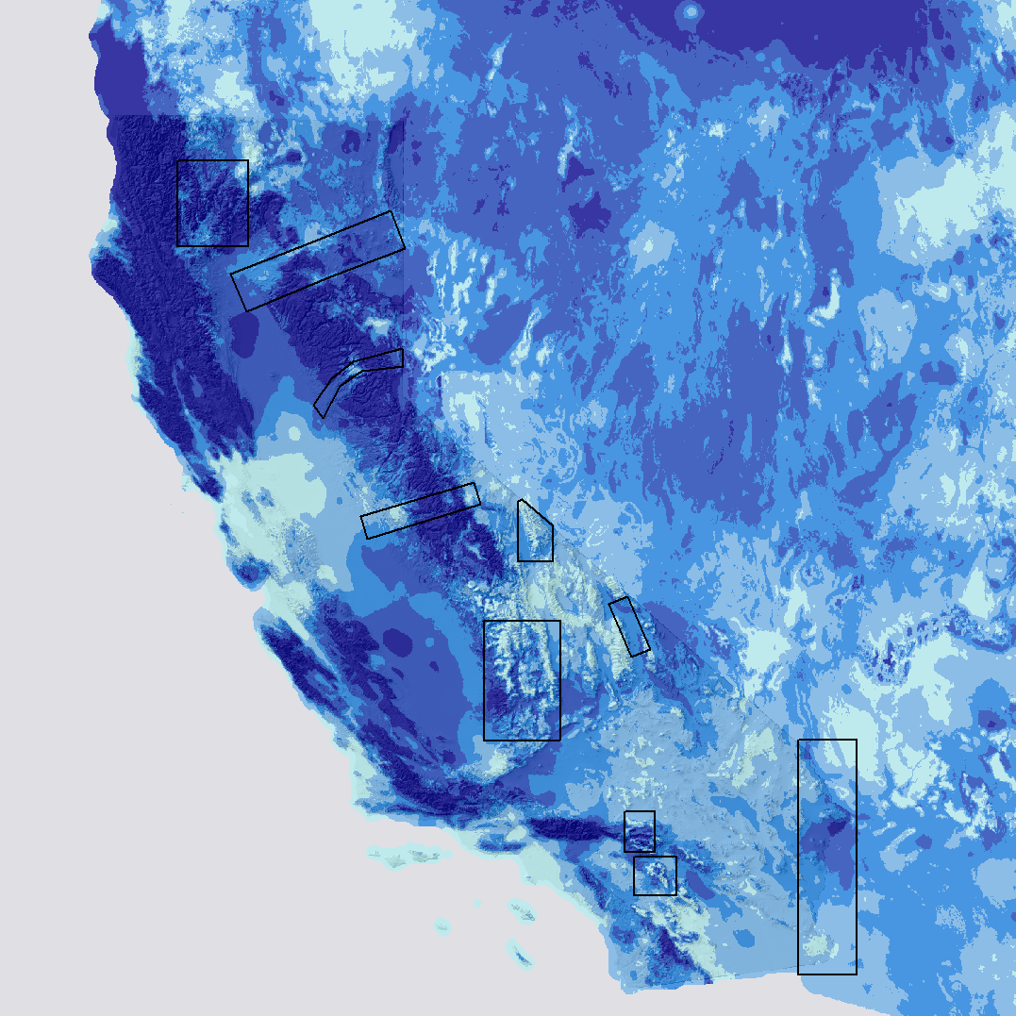

2. Next a principal components analysis was performed on the deltas of the 19 bioclimatic grids (=difference between historic and current for all 19 bioclim variables, such that high values are increases in the current era)

Eigenvalues
1.74E+07 | 2.03E+06 | 9.91E+05
Eigenvectors
Input | Layer
1 | 0.001010 | -0.000896
2 | 0.001187 | -0.005872
3 | 0.000018 | -0.000357
4 | -0.032860 | 0.871791
5 | 0.002071 | 0.009413
6 | 0.000578 | -0.015374
7 | 0.001493 | 0.024787
8 | -0.005921 | -0.006095
9 | 0.001709 | -0.003364
10 | 0.000187 | 0.008260
11 | 0.001157 | -0.016481
12 | -0.793247 | -0.226997
13 | -0.182114 | 0.108101
14 | -0.018528 | -0.014472
15 | 0.000038 | 0.000262
16 | -0.456172 | 0.044038
17 | -0.031838 | -0.046151
18 | -0.015230 | -0.250399
19 | -0.356068 | 0.329281

Below is the visualized first two components, again on the PC1 on Red band and PC2 on Green/Blue band:
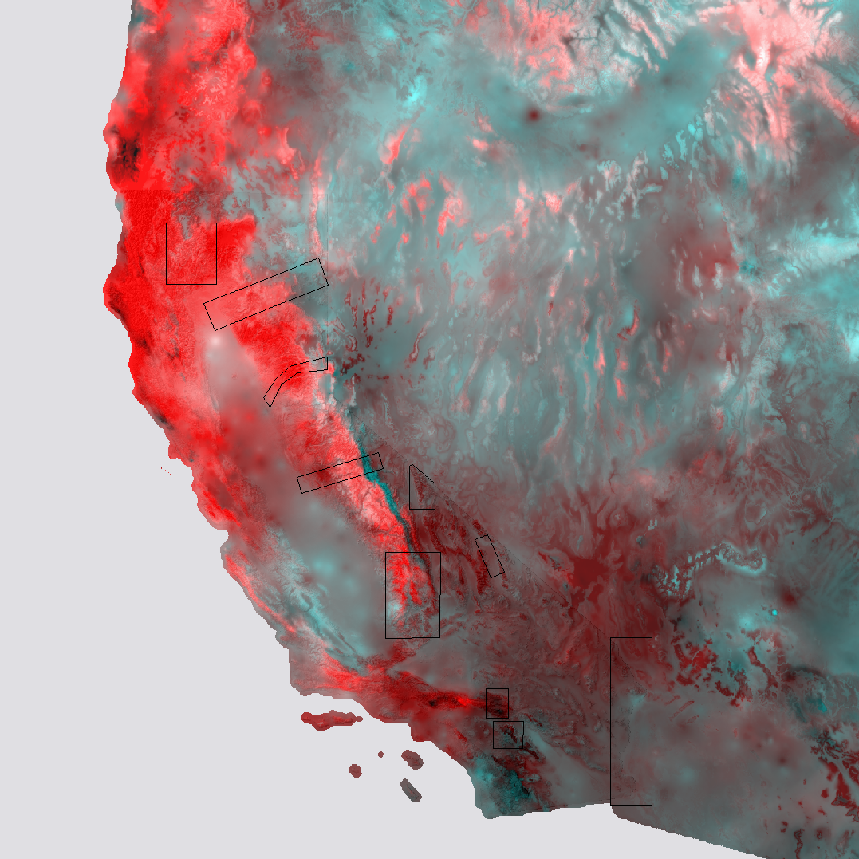

II. Site by site basis:
Below are all sites, both historic and modern, analysed together, and plotting the direction of change from the historic era values to the modern. The isolated group of green arrows, showing increased loading in the second component are all sites within the Lassen Volcanic NP.
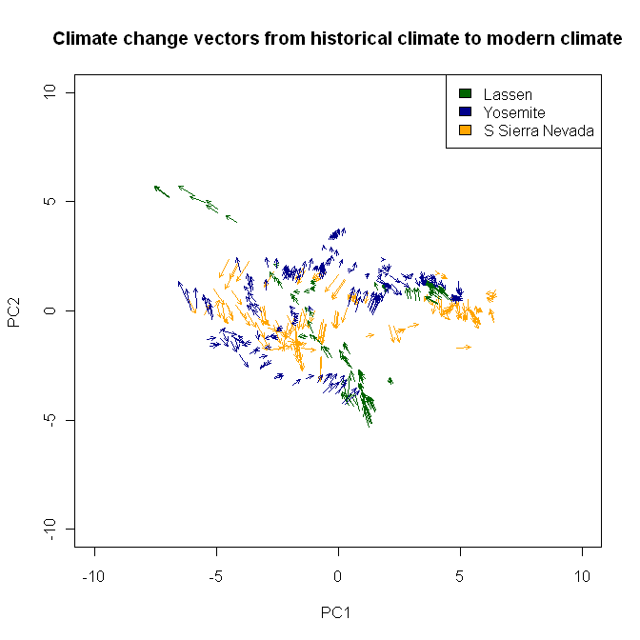
(add table of PC loadings on sites)

Since PC 1 corresponds with Temperature variables and PC2 with Precipitation ones, it may be easier to intuitively grasp the changes in the following when pared down to Annual Mean Temp and Annual Precip:
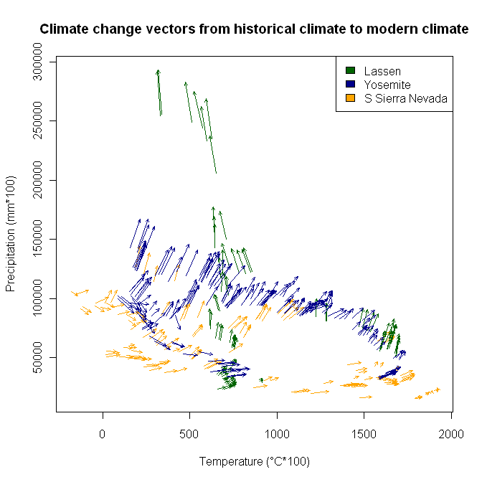
(Looks a lot like the change vectors for Morgan’s data. )

